CHINA LANGCHEM INC. CERTIFICATE OF ANALYSIS

Product ID: 2025 CAS: 51417-51-7
Product: 7-bromoindole Batch NO.: LC-2009090809

Manufacture Date: 2009-8-09 Analysis Date: 2009-08-10

Structure:
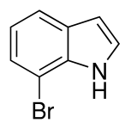

Formula: C8H6BrN
Molecular Weight: 196.04
Inspection Standard Results
Appearance: white solid Conformed
Purity (HPLC): 97% 98.8%
HNMR: Conformed
Storage: Stored in a cool dry place
Conclusion: This product by inspection accords with the standard corporation.

